Test Station Development Using the UCF Framework v030123
Richard Todd
Test Engineering Services
Requires libTeSequencer.(so | dll) v012623 or later.
Requires UniConsole(.exe) v012623 or later.
Requires StdIOChannelSystem(.so | dll) v012623 or later.

Purpose
This document defines the process to develop, verify and deploy an automated test station using the UniConsole Framework (UCF).
The focus of this document is primarily on using the UCF to integrate and automate the test station.
The intended audience for this document are test engineering developers using the UCF to build, automate and verify an electronic functional test station.

Terminology
Term | Definition
UCF | The UniConsole Framework
Test Spec (ification) | A document that defines each parameter to be tested, and the generic methodology used to create the measurement value.
Management Console | The tab/text based console that is used to monitor and control all application functionality
Test Executive | The user interface used to automatically sequence all tests and save measurement data to a local database
Go-nogo | A test sequence initiated by the test executive will stop on the first measurement failure
Host Computer | The computer that will control the test station’s instrumentation
Test Profile Group | The ‘./ucfroot/opt/MyTestGroup/’ directorycontains the ‘Test Profile’ subdirectory as well as a common IO configuration database.
Test Profile | The ‘./ucfroot/opt/MyTestGroup/INSTANCE’ directory that contains 1 or more shared libraries that will be automatically loaded in order to create the test application.
Test Project Directory | The directory used to create a new test automation application. The initial contents are copied from ./ucfroot/usr/src/_TplModule/*
Takt Time | Takt time is the average time interval between the start of production of one unit and the start of production of the next unit when items are produced sequentially.
System Variables | Text or numeric variable definitions stored in a UCF embedded database
Path-Link | Symbolic link definitions stored in a UCF embedded database
DUT | Device under test

Related Documents
Document | Description
UCF Introduction Notes.pdf | This document provides an introduction to the UCF user interfaces and deployment structure
UCF Test Executive Configuration Notes.pdf’ | This document defines the UCF test executive configuration process
UCF Installation Guid.pdf | This document defines the UCF installation process
UCF Module Development Guide.pdf | This document details the UCF module development process

Pre-Conditions
The following p reconditions are required before using this document:

Initial Test Specification
A test specification and test plan defines the requirements for both test system design as well as test program development.

Each parameter to be tested is defined

The generic measurement methodology for each parameter is defined.

Projected Takt time for the test station

Test Station Hardware Design and Fabrication
The test station is designed and fabricated using the test specification as performance requirements.

Instrumentation addresses are documented (Ethernet, Serial, etc) for use in the UCF framework

UCF Installation
The UCF is installed on the development computer.

See ‘UCF Installation Guide.pdf’ for installation details.

The Development Process Outline
This section provides an overall outline of the test station development process.

A Test profile is created using the template provided in the UCF distribution.

A Qt or Visual Studio C++ project is created to develop a test application.

Instrument control code is developed and verified

UUT test code is developed and verified

Test Profile Creation
This section outlines creating a test profile and test profile group.
A ‘test profile group’ is a directory containing common resources and 1 or more subdirectories that contain test applications. Common resources include:

Utility module requirements (utility UCF plugins)

Instrumentation addressing requirements

System Variables

Path-Link definitions

Creating the Test Group & Profile Structures
A test group directory structure is created using a copy of the sample structure (./ucfroot/opt/GroupTpl/ ) in the UCF distribution.

The new Test Group’ is named ‘PcbFunctional’ and the TestProfile ‘INSTANCE’ is renamed to ‘TestSuite_1’
~/ucfroot/ (or c:\ucfroot\)
:
├── opt/
│ └── GroupTpl/
: │ ├── Etc/
: │ ├── ExtendedCommands/
: │ ├── CommonLibs
│ ├── ExtSystemIO.sdb
│ ├── PathLinksEx.sdb
│ └── INSTANCE/
│ ├── LastTest.log
│ :
│
└── PcbFunctional/
├── Etc/
├── ExtendedCommands/
├── CommonLibs
├── ExtSystemIO.sdb
├── PathLinksEx.sdb
└── TestSuite_1/
├── LastTest.log
:

Directory and File Descriptions
Directory or Filename | Description
./Opt/ | The directory containing 1 or more test groups
./PcbFunctional/ | A test profile group that contains 1 or more test profiles with their common resources
./Etc/ | Misc configuration files used by all local profiles
./ExtendedCommands/ | External programs and utilities used by all local profiles
./CommonLibs/ | Shared libraries that are automatically loaded when executing and local profiles.
ExtSystemIO.sdb | Sqlite database containing system variable and instrument addresses used by all local profiles
PathLinksEx.sdb | Sqlite database containing directory and filename aliases used by all local profiles
./TestSuite_1/’ | A unique test profile.  This sub-directory is the target for Qt & Visual Studio C++ projects.

Qt or Visual Studio Project Creation
This section provides an overview of how to create a test application project using Qt or Visual Studio. The project and support files are found in the distribution directory.

./ucfrooot
└── usr
└── src
├── TplModule
│ ├── CMakeLists.txt
│ └── src
│ ├── TplModule.cpp
│ └── TplModule.hpp
│
├── UCF-<Distribution Name>
: └── Api
: ├── ...
: :

Project Creation
The project is created using the template project.

Copy the ‘TplModule’ directory and contents to any location desired.
./ucfroot/usr/src/<your project name> is recommended.

Project Configuration
The project is configured by editing the CmakeLists.txt file.

Configure the CmakeLists.txt to use the correct directories for all source files.

Configure the CmakeLists.txt to create the output in the ‘TestSuite_1’ profile directory (see section 6).

Open the CmakeLists.txt file directly with Qt, or use cmake to create the Visual Studio project.

Project Verification

Verify the project by ‘Rebuilding All’.

Execute the project output using the following command line syntax:
‘./ucfroot/bin/UniConsole(.exe) -c ./ucfroot/opt/PcbFunctional/TestSuite_1’

Utility Functions
Utility functions are UCF API functions that have been registered in the Management Console.
Test stations can be interactively controlled using the command line input to invoke utility functions that have been registered with the framework.

Showing Available Commands
Entering ‘help’ and the command line input will show a list of registered commands.
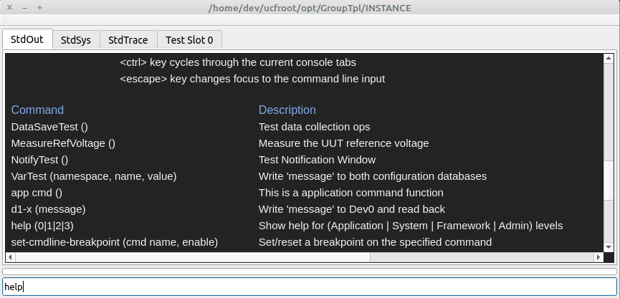

Executing a Registered Command.
A registered command can be executed by entering the name in the command line input.
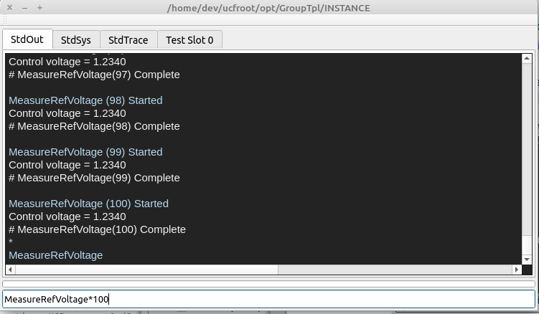

‘MeasureRefVoltage <cr>’ will execute a single instance of the command

‘MeasureRefVoltage * 100 <cr>’ will execute the command sequentially 100 times

The command line input uses ‘tabbed command completion’ as necessary

Registering a Utility Function
A utility function is registered in the TplModule.h/cpp files using the following code:
int TplModule::Start() {
/* Register the function to be called from the command line */
if (Cmds) {
Cmds→RegisterApplicationCmd(
"MeasureRefVoltage",
new Ucfx(&TplModule::TestInstrumentControl,this),
"(range), resolution)\tMeasure a voltage"
);
}
return(1);
}

Where
  - “MeasureRefVoltage” is the name of the command
  - TplModule::TestInstrumentControl is the name of the function to be registered
  - "(range), resolution)\tMeasure a voltage" is the command description that will be displayed when the help command is executed

Test Sequences Functions
A test function is a UCF API function that is registered in the test executive. Multiple registered functions will create a test sequence.
A UUT is tested by executing a sequence of test functions. Test sequences are invoked using either the UCF test executive or management console..

A test session is a group of 1 or more test sequences.

A test sequence is a group of 1 or more registered test functions.

Test Sequence Execution using the Executive
Execution using the graphical test executive is intuitive and is primarily intended to be used by test operators and technicians.
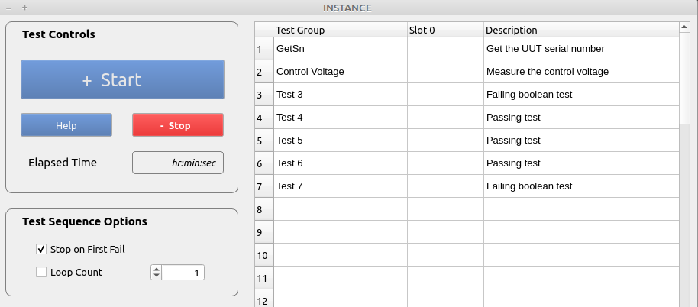

Options
  - The test sequence is executed by selecting the ‘Start’ button.
  - The ‘Stop’ button will synchronously terminate a test sequence
  - When the ‘Stop on First Fail’ checkbox is selected, execution will stop after the first failure.
  - When ‘Loop Count’ is selected, the test sequence will be executed ‘n’ times consecutively.

Test Sequence Execution using the Management Console
Test sessions, sequences and functions can be interactively executed using the Management Console command line input.
This method provides far more flexibility than the graphical test executive interface and is intended to be used during develop, validation and system debug.
When a test sequence is executed from the console, the GUI test executive will be updated with in-process test results and all data is saved.
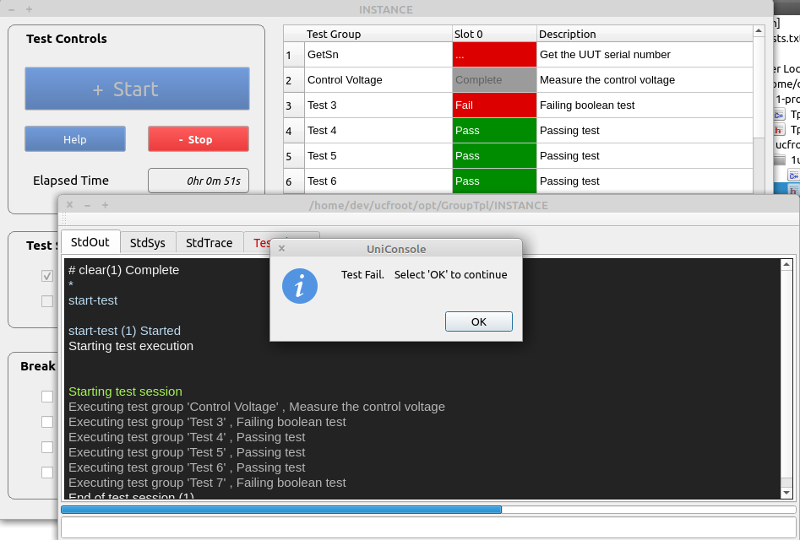

Test Session Options
  - ‘start-test’ will execute a single sequence that does not stop on first fail
  - ‘start-test,1’ will execute a single sequence that stops on first fail
  - ‘start-test*100’ will execute 100 consecutive sequences
  - ‘abort-session’ will asynchronously abort a test session at the end of the current test step
  - ‘stop-session’ will synchronously abort a test session at the end of the current test sequence

Test Function Execution using the Management Console
Interactively executing test functions from the command line is an important tool for test development and station maintenance.
This capability eliminates the need to modify code (comment out sequence functions, and rebuild the module, etc) in order to execute a single test.
- Data is displayed in the ‘StdOut’ tab
- The GUI test executive is not updated
- The test data is not saved to the database
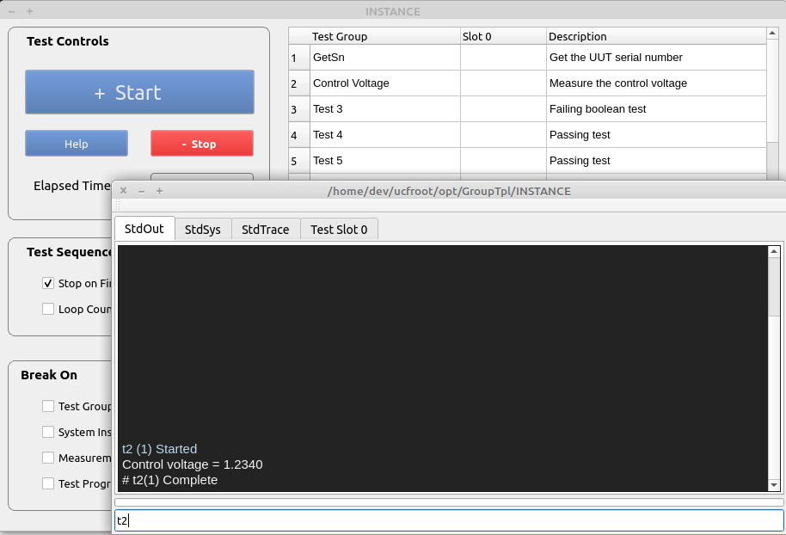

Command Options
  - ‘t2’ will execute the registered test function (‘Test Control Voltage’ from the test executive)
  - ‘t2 *100’ will execute the registered test function 100 times

Registering a Test Function
API functions will appear in the test executive (and execute) in the order of registration.
The first registered API function is meant to verify or input the UUT serial number and nothing else.
A test function is registered using the following code:
int TplModule::Start() {
/* Register the function to be called from the command line */
if (Cmds) {
Cmds→RegisterApplicationCmd(
"MeasureRefVoltage",
new Ucfx(&TplModule::TestInstrumentControl,this),
"(range), resolution)\tMeasure a voltage"
);
}
return(1);
}

Where
  - “MeasureRefVoltage” is the name of the command
  - TplModule::TestInstrumentControl is the name of the function to be registered
  - "(range), resolution)\tMeasure a voltage" is the command description that will be displayed when the help command is executed

UCF API Functions
UCF API functions are used to create either utility or test functions. API functions

May be executed by the test executive

May be executed from the command line input.

Function Format
All API functions have the following standard format:
int TplModule::MeasureControlVoltage(CmdParam msg) {
/* Measure a voltage and display the value in the StdOut tabbed window */
double measurement_value {1.234};
/* The variable is for demo purposes only */
iUcfTestExec exec(msg,ModuleId);

measurement_value = iSystem->MeasureControlVoltage();
/* Demo code that will execute when invoked by the console and test executive */

if (exec.IsValid()) {
/* Code that will execute when invoked by
1. The test executive
2. The ‘start-test’ command
*/
exec.SaveMeasurement("Test A","IsValid",measurement_value,1.0,3.0);
/* Save a measurement to the database and set the
initial pass/fail limits in the test limit database on the first call
1. 1.0 is the low test limit (value >= 1.0)
2. 3.0 is the high test limit (value<=3.0)
*/
exec.SaveMeasurement("Test B","IsValid",measurement_value,1.0,3.0,false);
/* Save a measurement to the database and use the passed test limits only.
The test limit database values are ignored
1. 1.0 is the low test limit (value >= 1.0)
2. 3.0 is the high test limit (value<=3.0)
*/
exec.SaveMeasurement("Test A","IsValid",measurement_value,15);
/* Save a measurement to the database and set the pass/fail limits in the test limit database as a percentage on the first call.
of the measurement value
1. measurement_value-15% is the low test limit (value >= 1.0)
2. measurement_value+15% is the high test limit (value<=3.0)
*/
exec.WriteTestOuput(“A message”, <Option>);
/* Display messages to the current test slot tabbed console output */
}
else {
/* Code that will only execute when invoked by the console */
StdOutConsole.Write(
IOString("Control voltage = %2.4f",measurement_value), <Option>
);
/* Write a message to the StdOut tabbed console output */
}
return(1);
/* ‘1’ is always returned */
}

<Option> is defined as one of the following values:
iStdOut::Pass // green text
iStdOut::Warning // yellow
iStdOut::Error // red text
iStdOut::SystemSoftError // yellow text
iStdOut::SystemHardError // dark red text
iStdOut::Text1 // normal text
iStdOut::Text2 // normal text-1 point size
iStdOut::Text3 // normal text-2 point size
iStdOut::GrayText // gray text
iStdOut::ItalicText // white italic text
iStdOut::Directory // blue text
iStdOut::Filename2 // light blue text
iStdOut::Filename3 // yellow text
iStdOut::Filename3 // white text

Additional iUcfTestExec exec methods
The iUcfTestExec object contains the following methods:
  - iUcfTestExec* GetMfgId(unsigned &id, imx::IOString name, imx::IOString location);
/* Get the manufacturer ID from the configuration database */
  - iUcfTestExec* SetSn(const char *sn);
/* Set the serial number for the current UUT */
  - const char* GetSn();
/* Get the serial number of the current UUT that was input using the test executive dialog
*/

Instrument Control
The UCF provides the capability to connect to external instrumentation using a standard interface to control the instruments.
Connection types include:

Ethernet client and server

UDP client and server

Serial connections

Local files

Defining IO Connections
Address information for all IO connections is defined in an embedded Sqlite database.

~/ucfroot/bin/<UCF Release Name>/IOConfig/BaseSystemIO.sdb contains address information that is global to all profile groups.

~/ucfroot/opt/PcbFunctional/ExtSystemIO.sdb contains address information that is local to the ‘PcbFunctional’ profile group.

The DbBrowser for Sqlite application is used to edit instrument address information.

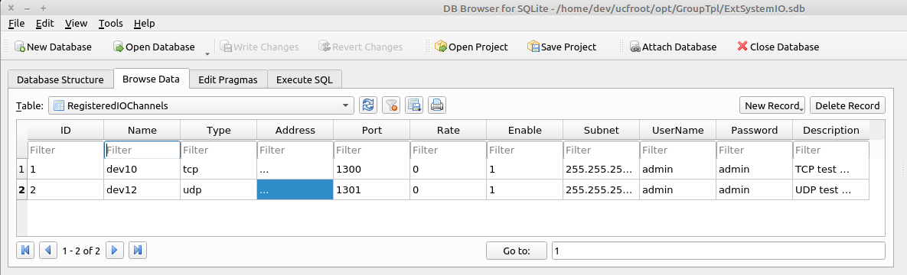
** This image is only representative of the database and may vary for older distributions

The contents of both databases can be viewed using the ‘ls-dev’ command.
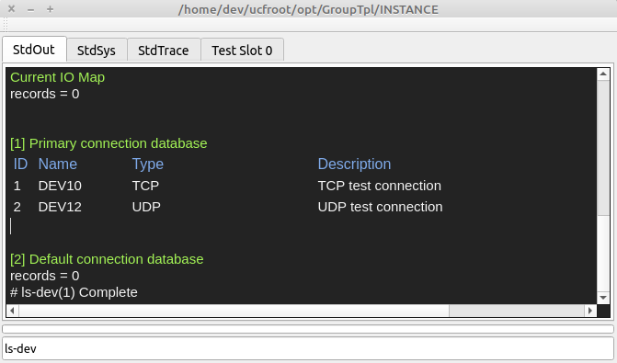

Creating Instrument IO Connections
Instrument connections are created on system startup and targets are verified to identify any connectivity issues as soon as possible.

Connections are created in TplModule::SetStaticConfiguration(…)

The TheSystem→RegisterIOChannelDevice(int device_id, char *description) function call is used to create and verify an instrument connection to the instrument.
Where:

int device_id corresponds to the name (dev0-n) in the adress configuration database
        - char *description is the description that will be displayed when executing the ‘ls-io’ command

An iIOConnectionDevice* will be returned on success, and nullptr on failure

The connection will be ‘cleaned up’ on program exit
Example Code

iIOChannelDevice *DvmConnection { nullptr };

void TplModule::SetStaticConfiguration() {
/* set the static configuration for the system
1. assign system interfaces to individual instruments
*/

DvmConnection=
TheSystem→RegisterIOChannelDevice(10,"Connection to the system DVM");
/* Open and verify connectivity a connection to an external instrument
1. The database entry for ‘dev10’ is used to create the connection
2. “Connection…” is the description that will be displayed when using
the ‘ls-io’ command
3. nullptr is returned on failure
4. For ethernet connections, the target is ‘pinged’ to verify he connection
*/
}

Viewing registered connections using the ‘ls-io’ command
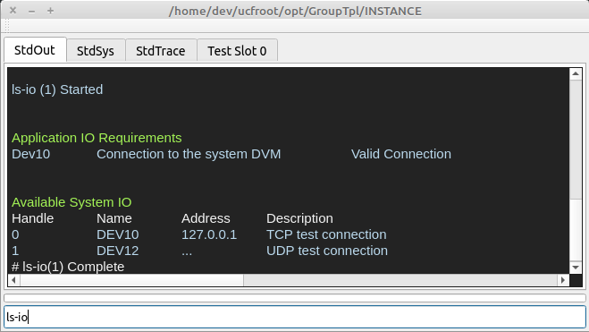

Initializing Instruments
Instrumentation should be initialized and configured at startup to minimize test times and to identify any related system issues as soon as possible.

Code is inserted in the TplModule::ThreadedStartup(…) function which executes on startup, in a seperate thread in order to keep the user interface responsive.

The progress bar will be active while the ‘ThreadedStartup(…)’ function is executing.

All exceptions that are thrown in the thread are caught at the end of the function and will lock the test executive to prevent test operations after a failed instrument configuration process.

The system locked state can be cleared using the ‘lock,0’ command.
        - The current system lock status can be viewed using the ‘lock’ or ‘status’ command
Example Code
void TplModule::ThreadedStartup(iIXmgr *ix) {
try {
TheAppEngine->iErrorManager()->LockEngine(true);
TheAppEngine→IncrementActiveThreadCount();

if (DvmConnection→Open()) {
DvmConnection->Write (“CONF:VOLT:DC 10,.001);
/* Set the full scale range and resolution */
...
}

TheAppEngine->iErrorManager()->LockEngine(false);
}
catch(IOString msg) {
TheAppEngine->iErrorManager()->SetHardError(msg);
}
catch(...) {
TheAppEngine
→iErrorManager()
→SetHardError("Unknown exception while initializing the system");
}
TheAppEngine->DecrementActiveThreadCount();
}

Instrument Force & Measure Operations
Instruments can be controlled from UCF API functions using registered connections.
Example Code
int TplModule::ReadDvm(CmdParam msg) {
/* Configure and control an Agilent 34461 DMM */
float measurement_value {0};
iIOChannelDevice::Guard connection_guard(DvmConnection);
/* Open DvmConnection
1. An exception will be thrown if the connection cannot be opened
2. connection_guard has the same API as DVMConnection
3. The connection will be automatically closed when connection_guard
goes out of scope
*/
connection_guard->Write (“READ?”);
TokenString result(connection_guard->GetReadBuffer(),',')
/* Read the input voltage */
result.GetToken(1,measurement_value);
/* Parse the result */
StdOutConsole.Write(
IOString("Control voltage = %2.4f",measurement_value),
iStdOut::Text1
);
/* Display the result to the StdOut console */

return(1);
}

Shutting Down Instruments
Instrumentation should be set to an ‘idle’ state on program termination.
The TplModule::Shutdown() function is automatically called on program termination.
Example Code
void TplModule::Shutdown() {
/* Shutdown the lib on program termination
1. Set any instrumentation to an idle/safe state
2. De-allocate as necessary
*/
iSystem→DisableSystemPowerSupplyOutput(…);
/* This is a demo function to disable the system power supply’s output */
}

A generic code interface used to configure and control instrumentation is required to write ‘instrument independent’ test applications.
This section defines the process for creating system configuration and control code.

Instrument address configuration

Create instrument connections

Interactively develop instrument initialization and control code

Automatically configure instruments on application startup

Instrument Address Configuration

Create Instrument Connections

Create an Instrumentation Abraction Layer

An abstract model of the system is created to provide and instrument independent system instrumentation interface.

The example code provides a simplistic example of an object based abstraction layer.

Class iProtoSystem {

Public:

iProtoSystem() default;

virtual void ConfigureSystemPowerSupply(iStdIOChannelDevice *ps)=0;

virtual void ConfigureSystemDmm(iStdIOChannelDevice *dmm)=0;

virtual double MeasureVoltageInput()=0;

virtual void SetSystemPowerSupplyOutput(double value)=0;

virtual void DisableSystemPowerSupply()=0;

Virtual ~iProtoSystem() { }

};

class ProtoSystem:public iProtoSystem {

ProtoSystem() { … }

void ConfigureSystemDmm(iStdIOChannelDevice *dmm) override {

TheDmm=dmm;
if (TheDmm→Open()) {
TheDmm->Write (“CONF:VOLT:DC 10,.001);
/* Set the full scale range and resolution */
...
}

}

double MeasureVoltageInput() override {

double measurement_value {0};

TheDmm->Write (“READ?”);
TokenString result(TheDmm->GetReadBuffer(),',')
/* Read the input voltage */
result.GetToken(1,measurement_value);

/* Parse the result */

return(measurement_value);

}

void ConfigureSystemPowerSupply(iStdIOChannelDevice *ps) override {

/* Set the power supply IO connection and configure the current limit */

ThePowerSupply=ps;

ThePowerSupply→Write(“CURRENT:PROT 5”);

}

void SetSystemPowerSupplyOutput(double volts) override {

ThePowerSupply→Write(IOString(“VOLT %2.4f”,volts));

}

void DisableSystemPowerSupply() override {

ThePowerSupply→Write(“SOUR:OUTP:STAT OFF”);

}

virtual ~iProtoSystem() { }

private:

iStdIOChannelDevice *TheDmm {nullptr};

iStdIOChannelDevice *ThePowerSupply {nullptr};

};

Test Functions
Test functions are methods used to configure and measure groups of 1 or more test parameters.

Test Method Invocation
Test methods are invoked from the command line, or by selecting ‘Start’ in the UCF test executive.

Test Method Creation
int TplModule::TestReferenceVoltageOutput(CmdParam msg) {
/* Test the reference voltage output from the UUT */
iUcfTestExec exec(msg,ModuleId);
double measured_voltage {0};

iSystem→SetSystemPowerSupplyOutput(3.3);

measured_voltage=iSystem→MeasureVoltageInput();
if (exec.IsValid()) {
/* If the function was called by the test executive */
exec.SaveMeasurement("Reference_Output","Voltage",measured_voltage,2.5,3.0);
/* Save the measurement to the database
1. ‘Reference_Output’ is parameter group name
2. ‘Voltage’ is the parameter name
3. ‘measured_voltage’ is the measurement value
4. 2.5 is the initial low test limit
5. 3.0 is the initial high test limit
*/
}
else {
/* If the function was called from the command line */
TokenString params (msg,',');
/* Parse the command line parameters */
…
StdOutConsole.Write(IOString("Ref Voltage = %2.4f",value),iStdOut::Text1);
/* Display the result to the StdOut console */
}
return(1);
}

Register the Method as a Test Function
The method is registered in the UCF as a test sequence member that can be called interactively from the command line.
One or more test methods are registered to create a test sequence.
Example Code
int TplModule::Start() {
/* Register the function to be called from the command line */
if (TheTestExec) {
TheTestExec→RegisterTestMgr(
new obj<TplModule,
TestXtor>(&TplModule::ManageTestSequences,this)
);
/* Register the test sequence manager */

TheTestExec→RegisterTestFunction(
"GetSn", "()\tGet the UUT serial number",
new Ucfx(&TplModule::Test1, this)
);
/* The first registered test function is used to get
or verify the UUT serial number
*/
TheTestExec→RegisterTestFunction(
"Test 1", "()\tVerify the UUT reference voltage output",
new Ucfx(&TplModule::TestReferenceVoltageOutput, this)
);
/* Register the ‘TestReferenceVoltageOutput’ method */
...
...
TheTestExec→RegisterTestFunction(
"Test n", "()\tExample test method",
new Ucfx(&TplModule::TestExample3, this)
);
/* Register another test method */

}
return(1);
}

Invoking a Test Sequence
A test sequence can be invoked from either the command line input, or the GUI test executive.

Test Executive GUI

Execution using the Management Console

Command Line Input

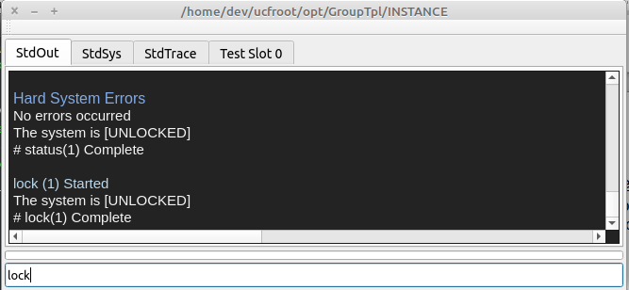

UUT Connections
UUT connections are created and disconnected ‘on the fly’ in test code. Connection errors are typically treated as a type of test failure.
Example Code

Example Code

Test System Integration
The test system ins assembled and integrated with the UCF prior to verification and development of specific functional tests. At the end of the integration, the system will be ready for test development.

Prereqisites

The test station has been assembled using the documentation created in section 7.3

The UCF is has been installed on the develolpment computer.

The Qt or Visual Studio IDE has been installed on the development computer.

A template project has been created for either Qt or visual studio.
See the ‘UCF Installation Guide.pdf’ for details.

System Abstraction Layer Development
A ‘system abstraction layer’ is an object that interfaces generic force and measurement commands to specific instrument control code.

The abstraction layer code is implemented in a C++ object.

The system abstraction layer is used by registered commands within an application module (TplModule.h/cpp) to innteractively control instrumentation
See ‘UCF Module Development Guide.pdf’ for details.
Example Code
int TplModule::MeasureControlVoltage(CmdParam msg) {
/* Create a measurement function to directly measure a test instrumentation input */

double measurement_value {1.234};
iUcfTestExec exec(msg,ModuleId);

measurement_value = TheAbstractionLayer.MeasureControlVoltage();

StdOutConsole.Write(
IOString("Control voltage = %2.4f",measurement_value),
iStdOut::Text1
);

return(1);
}

int TplModule::Start() {
/* Register a force/measure function to be called from the command line */
Cmds=TheAppEngine->iGet<CmdRepository::iMethodServer>(ModuleId);

if (Cmds) {
Cmds→RegisterApplicationCmd(
"MeasureRefVoltage",
new Ucfx(&TplModule::MeasureControlVoltage,this),
"()\tMeasure the UUT reference voltage"
);
}

return(1);
}

Force & Measurement Command Development
Each registered command can be debugged and verified using the Management Interface Console.
  - Type ‘help <cr>’ to see a list of available commands
  - Type ‘MeasureRefVoltage <cr>’ to execute the selected command.
Note: The console has ‘tab command completion. Typing ‘Me <tab>’ will select ‘MeasureRefVoltage’

Test System Verification
The test system is verified by using the UCF console to exercise all force and measurement calls provided by the ‘abstraction layer’. Each force and measurement call is a ‘Registered’ function within the application module.

Each force or measurement call is made 100 consecutive times.

The accuracy and repeatability of each call is documented and determined to be acceptable for the test measurements to be made.
  - Type ‘help <cr>’ to see a list of available commands
  - Type ‘MeasureRefVoltage*100 <cr>’ to sequentially execute the command 100 times.
Note: The console has ‘tab command completion. Typing ‘Me <tab>’ will select ‘MeasureRefVoltage’

  - Review the output and document the measurement accuracy and repeatability.

Test Sequence Development
This section outlines developing test sequences in a shared library that implement the measurements defined in the test specification.
Individual tests are functions that measures a parameter using calls to the system abstraction layer.
Test functions are then registered in the UCF test executive to create a test sequence.

Prerequisites
The following steps are required before implementing this section

Test specification development

Test station design & integration

Sequence Development Process

Test sequences are built using individual test functions for each parameter, or group of related parameters.

Test functions use generic force and measurement calls to create individual test cases that save data to the embedded database.

Test functions are ‘registered’ with the UCF test executive in order create a test sequence.

Example TplModule.cpp Code
int TplModule::TestControlVoltage(CmdParam msg) {
/* Create a measurement function to directly measure a test instrumentation input */

double measurement_value {1.234};
iUcfTestExec exec(msg,ModuleId);
measurement_value = TheAbstractionLayer.MeasureControlVoltage();
if (exec.IsValid()) {
/* If the function was called by the test executive */
exec.SaveMeasurement("Ref_Output","Voltage",measurement_value,1.2 ,1.8);
}
else {
StdOutConsole.Write(
IOString("Control voltage = %2.4f",measurement_value),
iStdOut::Text1
);
}

return(1);
}

int TplModule::Start() {
/* Create a test sequence using test functions*/
if (TheTestExec) {
TheTestExec→RegisterTestFunction(
"GetSn", "()\tGet the UUT serial number", new Ucfx(&TplModule::Test1, this));
TheTestExec→RegisterTestFunction(
"Control Voltage","()\tTest the control voltage", new Ucfx(&TplModule::TestControlVoltage, this));

…
}

Executing Test Sequences
Test sequences can be executed using the graphical user interface, or from the management console.

Validating a Test Sequences

Debug When Errors are Suspected

  - A BOM is created from the schematic.

The UCF Profile Group Creation
A profile group is a collection of 1 or more related test profiles that share common instrumentation configuration information.

The ‘ucfroot’ distribution package installation.
The ‘ucfroot’ directory from the installation package is copied to either ~/ for linux, or c:\ for windows.

Profile Group Creation
./ucfroot/opt/GroupTpl/* is copied into ./ucfroot/opt/MyTestGroup to create the target test group.

Test Project Directory Creation
A test project directory is created using the CmakeLists.txt and source files located in ./ucfroot/usr/src/_TplModule/*

./ucfroot/usr/src/_TplModule/* is copied to a user defined project location.

Test Project Configuration

The CmakeLists.txt is modified to reflect new template source code locations.

The CmakeLists.txt is modified to include any required files from ./ucfroot/usr/src/<Release Name>/Api.

The CmakeLists.txt is modified to build the shared library into Test Profile directory.

The CmakeLists.txt is used to create a new QT or Visual Studio project.
After the project is created, it can be maintained and updated without using cmake and the CmakeLists.txt file, if desired.

Instrument Communication and Initialization
****

UCF Overview
The UCF framework uses components that are deployed in a standardized directory structure.
- A GUI based management interface (console) that is used to interactively control the test station
- A GUI based test executive and sequencer that executes test sequences and saves data
- The UniConsole application and support shared libraries
- User defined shared library(s) that implement product specific test sequences
- Embedded configuration databases
- An embedded measurement data data-base

A standardized deployment structure simplifies current and future software maintenance and upgrades.

All stations developed by multiple test engineers will be configured identically.

All stations will retain the same deployment configuration over extended periods of time.

Multiple deployment schemes from multiple developers are avoided to reduce support requirements.
See ‘UCF Introduction Notes.pdf’ for detailed information

The Management Interface
The use of the management interface is the single most powerful development and maintenance feature of the UniConsole Framework.
The Management interface is a UCF specific console that allows a user to interactively control a test station and monitor real-time configuration and status information.

User defined test or utility functions can be interactively executed.

System instrumentation can be interactively controlled.

Complete test sequences can be executed 1-n times without requiring the GUI test executive.
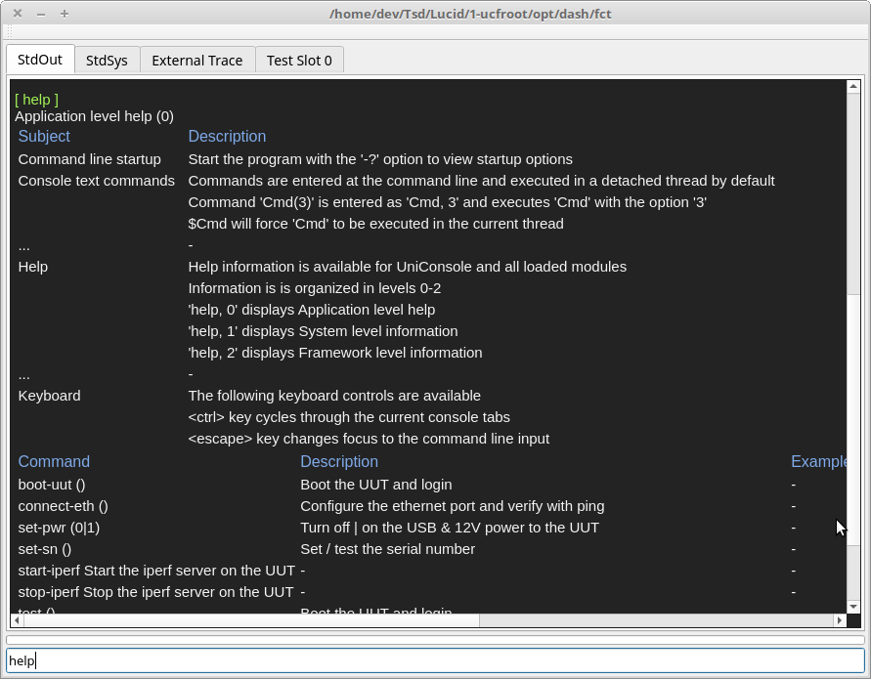
All interactive commands can be listed using the ‘help’ command.
Examples:

‘5*start-test’ will execute the registered test sequence 5 times

‘10*start-test, 1’ will execute the registered test sequence 10 times where each sequence will stop on first fail.

‘abort-session’ will asynchronously abort a test session at the end of the current test step.

‘stop-session’ will synchronously abort a test session at the end of the current test sequence.

‘tn <cr>’ will execute test #’n’ from the GUI test executive.

‘5*tn <cr>’ will execute test #’n’ 5 times consecutively.

‘5*tn,1 <cr>’ will execute test #’n’ 5 times consecutively with ‘gonogo’ mode enabled.

‘power, 0|1 <cr>’ will disable | enable system power where ‘power’ is a user defined & registered function.

See ‘UCF Introduction Notes.pdf’ for detailed information.

Configuration Settings
The following test executive startup settings can be configured using system variables. These settings are optional.

Management Console GUI interface size and location

Test Executive GUI interface size and location

The initial test mode (Go-nogo)

The manufacturer's name and location of the test station

Test specifications, parameters and limits for each test profile

The number of units to be tested concurrently

Manual UUT serial number verification

System variables
System variables are stored in local or global sqlite databases and are configured using the ‘DB Browser for Sqlite’ application.

Locations
Database Type | Database Location | Platform
Local | ~/ucfroot/opt/<Profile Family Name>/ExtSystemIO.sdb | Linux
 | C:\ucfroot\opt\<Profile Family Name>\ExtSystemIO.sdb | Windows
Global | ~/ucfroot/bin/<Release Name>/IOConfig/BaseSystemIO.sdb | Linux
 | C:\ucfroot\bin\<Release Name>\IOConfig\BaseSystemIO.sdb | Windows

Local database values are unique to a specific profile family and will override values in global databases.

Global database values will be used for all profiles that do not have overriding values in a local database.

User Interface Configuration
The Management Console and Test Executive user interface can be optionally configured using system variables.
- Management Console window size & location
- Test Executive window size & location
- Initial test mode (Go-nogo enable)

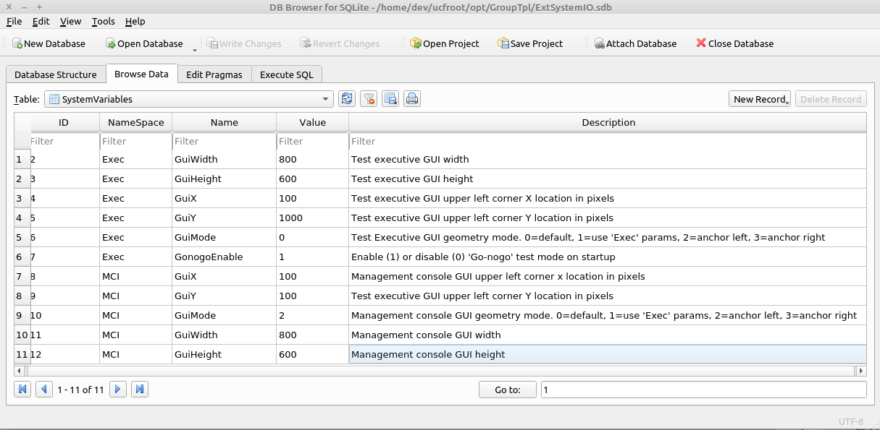

Where
‘Exec::GuiMode’ specifies the display mode of the test executive user interface.
0=default
1=use ‘Exec’ system variables to set geometry
2=anchor left
3=anchor right
‘MCI::GuiMode’ specifies the display mode of the management console user interface.
0=default
1=use ‘Exec’ system variables to set geometry
2=anchor left
3=anchor right
‘Exec::GuiMode’ specifies the execution mode of the test executive on startup.
0=Do not stop on first test failure
1=Stop on first test failure

Test Specification Configuration Process
The test executive is designed to use test limits from a version controlled test specification. Each parameter saved in the database is traceable to
- The test specification used to determine pass/fail status
- The manufacturers name and physical location
- The test station used to save the parameters
Test specification information is stored in local sqlite database and is configured using the ‘DB Browser for Sqlite’ application.

Database Type | Database Location | Platform
Manufacturing ID | /var/lib/ucf/Static.sdb | Linux
 | C:\ucfroot\var\lib\Static.sdb | Windows
Test Specifications | /var/lib/ucf/TestLimits.sdb | Linux
 | C:\ucfroot\var\lib\TestLimits.sdb | Windows

Manufacturing ID
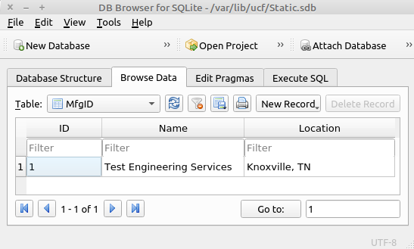

‘Name’ is the name of the manufacturing company.

‘Location’ is the location of the manufacturing company.

Only the first record is used. All additional entries will be ignored.

Test Specification(s)
Any number of test specifications can be set in the TestLimits::TestSpecIndex table.

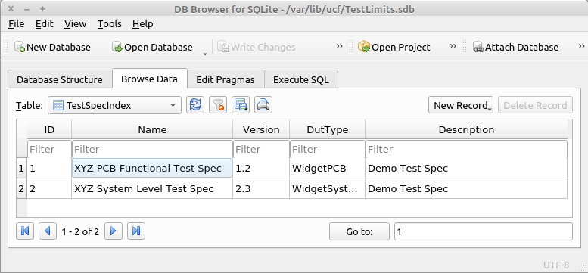

‘ID’ is the numeric identifier used to reference each test specification

‘Name’ is the name of the test specification

‘Version’ is the version of the test specification. Multiple versions can be specified

‘DutType’ is the name/type of UUT to be tested

‘Description’ is a brief description of the test specification

Test Profile Maps(s)
The test profile map table specifies which test specification will be used for each UCF profile.

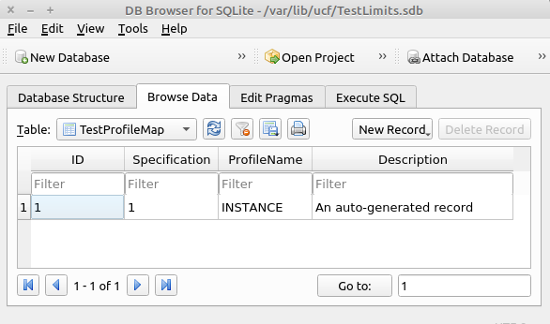

Specification’ corresponds to a test specification ID defined in TestLimits::TestSpecIndex

‘ProfileName’ is the last element in the file path specified when starting the UniConsole framework.

Example UCF startup command:
‘./UniConsole(.exe) -p /home/dev/ucfroot/opt/GroupTpl/INSTANCE‘
Where INSTANCE is the profile name

Test Limits
The test profile map table specifies which test specification will be used for each framework profile.

This table will be automatically populated the first time the test sequence is executed and will use the the
default values specified in the test program. Subsequent test sequence executions will not modify the test limits.

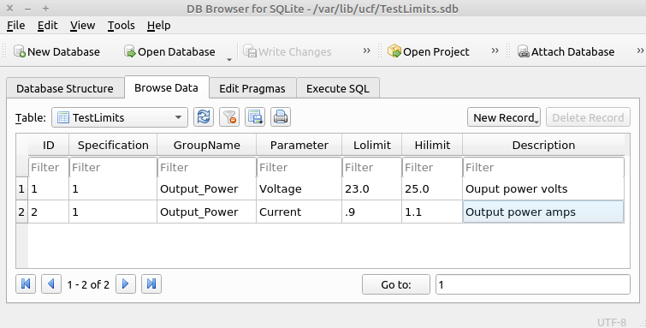

Specification’ corresponds to a test specification ID defined in TestLimits::TestSpecIndex.

‘GroupName' is a category or namespace.

‘Parameter’ is the name of a specific measurement.

‘Lolimit’ is the lower pass/fail threshold. Passing values are >= ‘Lolimit’.

‘Hilimit’ is the upper pass/fail threshold. Passing values are <= 'Hilimit.

Slot Count & Verify Serial Number
The framework is capable of testing 1-16 UUT's concurrently and can require that a serial number be manually entered at the start of a test sequence. These values are optional and will default to ‘1’.

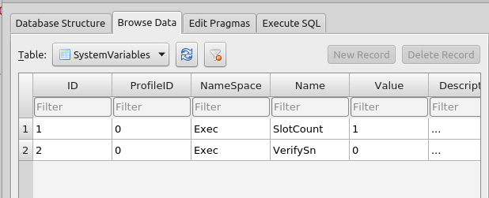

‘ProfileID’ is not used.

‘NameSpace’ = ‘Exec’

‘Name’ = ‘SlotCount’ | ‘VerifySn’

‘SlotCount’ is the number of units to be tested concurrently (1-16).

‘VerifySn’ enable/disables manual input of a serial number at the start of a test sequence.

See section 3.2 for additional system variable information

****

Prereqisites

The test station has been assembled using the documentation created in section 7.3

The UCF is has been installed on the develolpment computer.

The Qt or Visual Studio IDE has been installed on the development computer.
See the ‘UCF Installation Guide.pdf’ for details.

  - ‘MeasureRefVoltage <cr>’ will execute a single instance of the command
  - ‘MeasureRefVoltage * 100 <cr>’ will execute the command sequentially 100 times.

